Autumn/Christmas Newsletter 2022
We hope you are staying warm and well during these cold and challenging months. Our team have been extremely busy since the summer and in our latest newsletter we are proud to share news of exciting developments to our service, most notably the establishment of our Volunteer-Led Services (Transport and Befriending) and our Fundraising Support Programme for local community groups. In the midst of our current Cost of Living crisis, we'll also be focusing on the various ways that we and the local organisations we work with can help isolated residents facing financial hardship. Below you will find the following sections:

~ Christmas Meals
~ Cost of Living Crisis
~ Transport & Befriending
~ Support for Local Groups
~ Client Testimonials
~ Connect with CCL

~CHRISTMAS MEALS~

If you or someone you support in Lewisham will be alone this Christmas and could benefit from a free meal and some company then please sign up for one of our Christmas meal projects:
Free Christmas Lunch
~ Monday 19th Dec at the Catford Constitutional ~
Lewisham residents aged 50+ are invited to attend our free Christmas lunch at the Catford Constitutional Pub (108 Rushey Green SE6 4HW). The meal will be from 12 midday- 2pm and we'll be providing a three-course traditional Christmas meal plus some live musical entertainment! To sign up please call our phone line on 0330 0583 464. There are 50 places in total and still plenty left so please do share this with any isolated person you may know or support who would be benefit!
Free Christmas Meal delivery
We are also offering a free Christmas meal delivery for any Lewisham residents who will be spending Christmas alone, and aimed especially at those who have difficulty leaving their home. Meals will be prepared by our project partners Catford Salvation Army and delivered by our volunteers on Friday 23rd December.
What will participants receive?
The meal will consist of traditional turkey and trimmings, Christmas pudding a hot drink sachet. Vegetarian, vegan diets and allergies are also catered for, but please note there can’t be other specifications (eg: prefer beef to turkey, doesn’t like parsnips, etc.). Meals are delivered cold in a microwavable container (including cooking instructions) and need to be consumed by 25th December. The parcel will also include a quiz sheet, a Christmas magazine published by the Salvation Army, a Christmas card and a Christmas cracker!
How do I request a meal/refer someone?
To request a meal delivery please call us on 0330 0583 464. The deadline for referring people for this is Wed 14th Dec. Please note there will be a maximum of 100 meals delivered, to be allocated on a first come first served basis.

Christmas Services & Food Support Factsheet
We have been working in partnership with Lewisham Local to provide an extensive list of what's available over Christmas across Lewisham. This includes opening times and contact details for useful services, as well as numerous free meals and food projects. You can now find the finalised list (also downloadable as a Factsheet) on our website HERE.

~COST OF LIVING CRISIS~
Support for people facing financial hardship this winter

Supporting Lewisham residents facing financial hardship is a vital, day to day aspect of our work. With the onset of our current cost of living crisis, the need for help around food access, energy bills, debt and benefits, has escalated greatly over recent months. In the last quarter alone our referrals and signposts included over 509 individuals to Lewisham Foodbank and 143 for energy related support from South London Healthy Homes. It’s now estimated that over half of UK households will face ‘fuel poverty’ (over 10% of net income going towards energy bills) by January 2023. It’s therefore more vital than ever that our most vulnerable residents know what support is out there!
Earlier this week we led a free ‘Cost of Living’ event at the Civic Suite in Catford, organised in partnership with energy saving experts South East London Community Energy (SELCE). The day also featured useful talks and stalls from a number of our local partners including Lewisham Foodbank, Advice Lewisham and Lewisham Local. It was great to see lots of residents come along and find out more about the different types of support available. These include:

- Help with switching to the cheapest energy tariff
- Free energy saving devices
- Help signing people up to money saving schemes such the ‘priority services register’ and ‘Water Help’.
- Food vouchers
- Free community meals
- Community Warm Spaces
- Free toiletries and stationary for 11-25 year olds
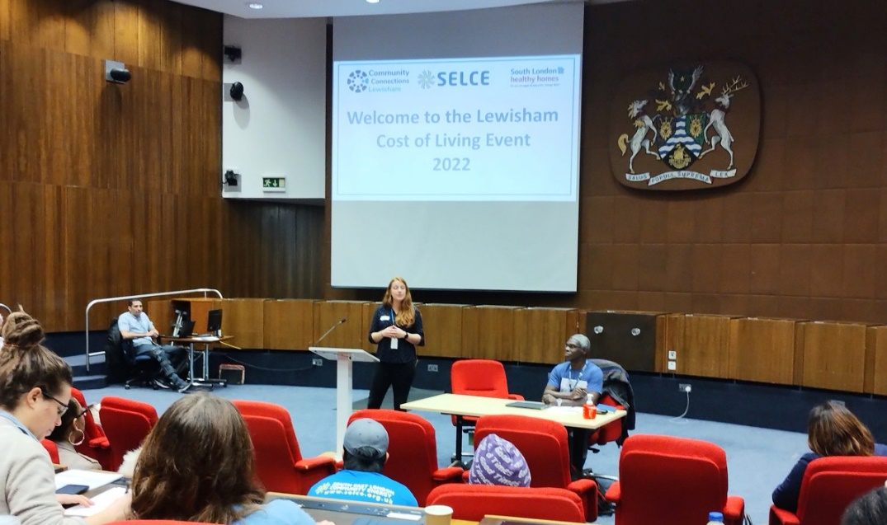
Our Partnership Coordination Manager Caroline speaking at our 'Cost of Living' event

Download our 'Financial Hardship' Factsheet
We recently compiled a 'Financial Hardship' factsheet, giving an extensive list of local services that support people facing financial hardship. Please read and/or download this HERE and share with anyone you know in need of support this winter.

~TRANSPORT
& BEFRIENDING~

Two new volunteer-led services launched: Transport & Befriending

This summer saw our team take on the delivery of two long established community services, formerly run by Voluntary Services Lewisham and now relaunched as Community Connections Transport and Community Connections Befriending. It’s been an incredibly busy and exciting time for our newly formed Volunteer Led Services team, meeting with existing volunteers and service-users alike to see how we can develop and improve each service, while also driving the recruitment of new volunteers in order to meet the high demand among Lewisham residents! Our hope is to be able to accept new referrals by the beginning of 2023.
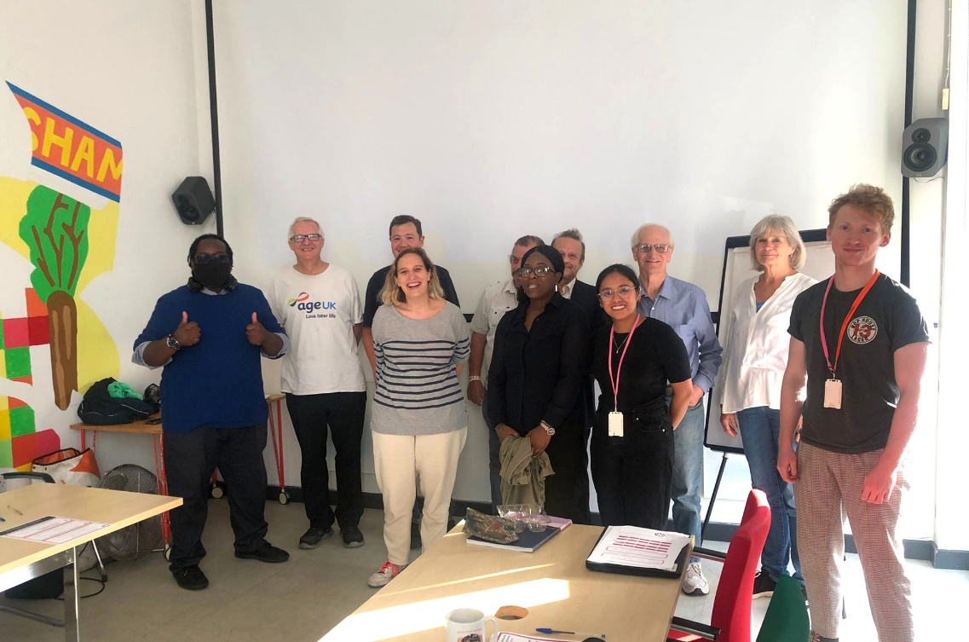
Members of our Volunteer Led Services team leading an early planning meeting with volunteer drivers at PLACE/Ladywell

What is it?
A volunteer-led transport scheme providing affordable journeys for disabled and vulnerable residents needing support to get around Lewisham and beyond. Alongside journeys in our volunteer’s cars, the project can also match volunteer ‘Travel Companions’ with residents who, though able to access public transport, struggle to travel alone due to issues including learning disabilities, visual impairment, or severe anxiety.

How much does it cost?
Return car journeys within the borough of Lewisham cost £10 total. Journeys outside the borough can also be arranged, though please note that additional driver expenses will be incurred.

How to refer/book:
We are now taking bookings for one-off return journeys. To request a booking for yourself or someone you support please phone our team on 0330 0583 464. Our line is open 9:30am-4pm Monday-Friday (*closed Thursday afternoons).
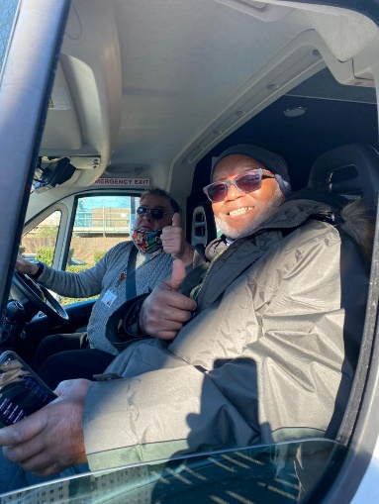
Regular CC Transport volunteers Paul and Stewart. Paul says ‘We really enjoy driving in Lewisham and find it rewarding to make a difference to the lives of others in our community'
Read more on our website Community Connections Transport page

What is it?
A project that recruits and trains volunteer befrienders to support housebound and isolated residents ('befriendees') through weekly telephone chats and/or home visits.

Why?
For those struggling with issues like loneliness, bereavement and long-term illness, it can make such a positive difference to have regular contact from a friendly, listening ear. There is a huge demand for befriending services across Lewisham, yet there remains a scarcity of local provision. We've been working hard to counter this through proactive volunteer recruitment, and expect to be in a position to accept new referrals from February onwards.
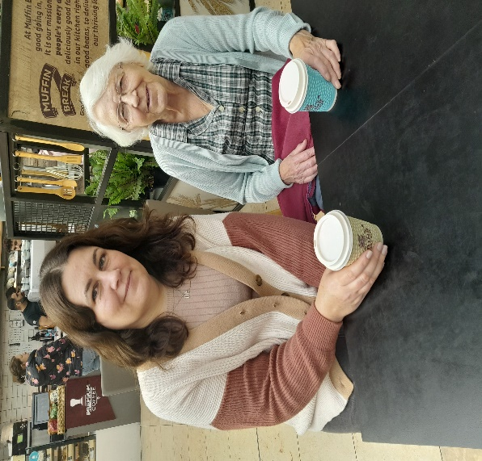
Volunteer befriender Melissa finally meeting her befriendee Marrie in person after 2 years of weekly phone chats
Read more on our website Community Connections Befriending

VOLUNTEERS NEEDED!
Could you or someone you know spare an hour or more each week to support an isolated resident? If so, we’d love to hear from you!
The success of our Transport and Befriending projects is wholly reliant on our team of dedicated volunteers. In order to meet the needs of our current waiting list and take on more referrals we need to recruit more befrienders, Car drivers and Travel Companions as soon as possible.
Find out more/Apply:
You can now download the role descriptions and apply to volunteer using our simple website application forms here:
Community Connections Transport ~ Volunteer Application page
Community Connections Befriending ~ Volunteer Application page
Please share this with anyone you know or support who is interested in volunteering opportunities!
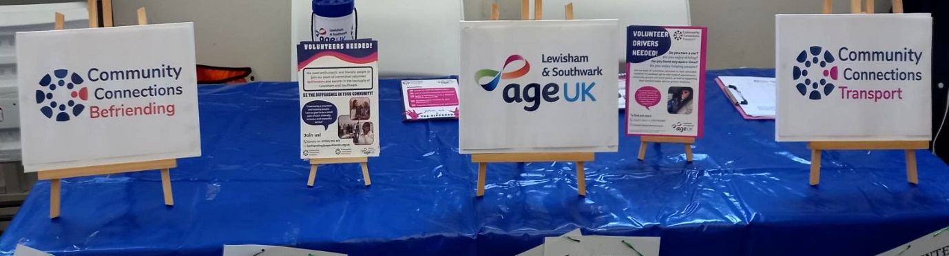

~SUPPORT FOR LOCAL GROUPS~

Alongside our client facing work, an essential way that we help to break social isolation in Lewisham is through our support for local community groups. Through a variety of ways we can help local groups, both fledgling and established, to sustain and grow their work, support their members and attract new ones!

Fundraising Support Programme:
We are delighted to now be able to offer free fundraising support for community groups, as part of an innovative new scheme funded by Lewisham Council and launched in September.
Leading this is our Fundraising Development Manager Leanne, who will be focusing on ‘cold spots’ – areas of support where the need is great yet the provision is low. Leanne’s expertise can help groups in a range of ways including one to one support with funding bids. Her first year priorities will be supporting groups delivering any of the following:
- One-to-one or group befriending
- Delivering work for the area of Downham
- Support for people with COPD or another respiratory illness
- Mental health support
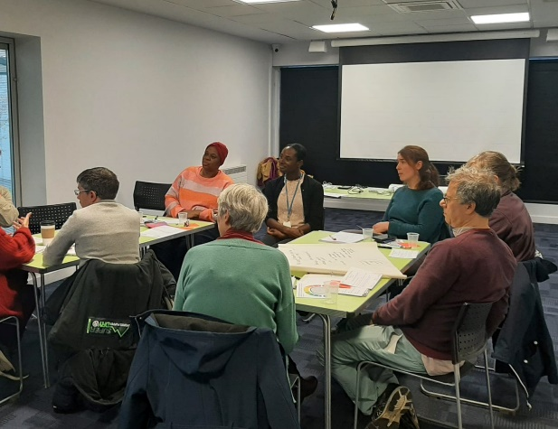
Leanne's Befriending Workshop last month at Forest Hill Pool brought together leaders of several local befriending services to work on a joint fundraising bid
To find out more please visit our new website page Fundraising Support

Further Support
Our dedicated Community Development Worker Michael is here to support local groups in a variety of ways, from help with publicity and fundraising to connecting you with other groups and initiatives.
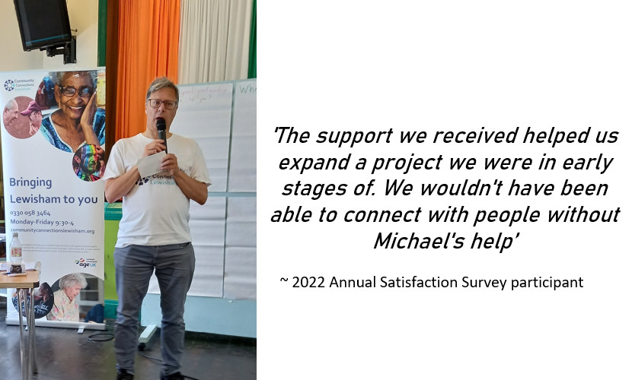
Join our Community Development Mailing List for regular updates on one or both of the following:
(1) Information on new groups and activities in Lewisham (ideal for professionals who signpost regularly!)
(2) Information for those who run groups e.g. resources, training, events
To sign up simply email michael.stuart@ageuklands.org.uk, specifying which mailing list you wish to join. You can unsubscribe at any time.
Find out more on our website pages:
Useful Information & Resources for groups
More about Michael’s work with local groups

~CLIENT TESTIMONIALS~

“I was in a really anxious situation with no electricity, the person on the phone was a godsend. It changed my whole week, I'm very grateful. It took me a step in the right direction because they really cared”

“I found Community Connections very non-judgemental and supportive. They made me feel more able and more positive about myself, less helpless, with more options that I could get involved in. It was a very positive experience.”
“An excellent service that can help, even if you think you're stuck. They will point you in the right direction, especially as a pensioner. The government didn't help me but they did”

‘We gained in confidence in applying for further funding, support makes us feel more part of Lewisham charity and voluntary sector’
(Local Community Group)
Taken from our 2022 Annual Satisfaction Survey

CONNECT WITH CCL

GET IN TOUCH
You can get in touch with us by calling our main helpline on 0330 0583 464. Our line is open from Monday-Friday from 9:30am-4pm, except on Thursday afternoons when we close at 1pm. You can also visit us at our free Weekly Drop-In, held each Thursday 2-4pm at PLACE/Ladywell, 261 Lewisham High Street, SE13 6NJ.
Find out what services are available in Lewisham for a particular support need - Online Community Directory
Our range of helpful factsheets are freely available to view and download from our website under HERE (please see 'Community Directory' heading). We continue to update and add to these, which include Financial Hardship, Employment Support, Digital Support and ESOL.
Get regular Email updates about local groups and services
To receive frequent updates on current provision of groups and activities around the borough please sign up to our Community Development Worker's mailing list by dropping a quick email to michael.stuart@ageuklands.org.uk
GIVE
This year we've been actively fundraising in order to expand our outreach to isolated residents and sustain services like our Drop-in and the new Transport and Befriending projects. Please visit our website DONATION PAGE where you can find out more and support our campaign.
THANK YOU

