
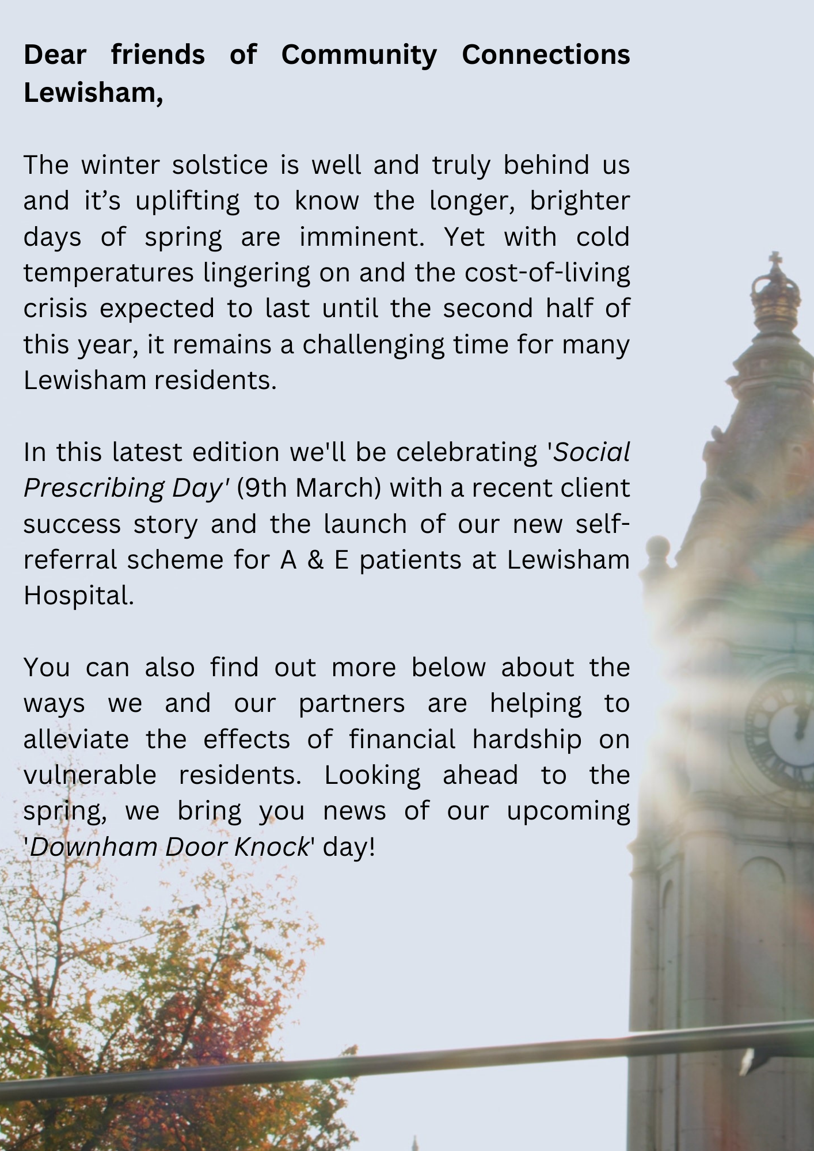
A&E Patient Self-Referrals launched on
Social Prescribing Day
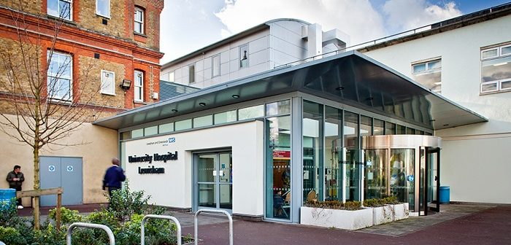
This week, on Thursday 9th March, we’ll be marking annual 'Social Prescribing Day' with the launch of our new patient self-referral scheme in Lewisham Hospital A&E department. Three large posters will go up, targeted at any adults waiting in A&E who are keen to explore local, free or low cost opportunities for Exercise, Creativity and/or Social Activity. Each poster has its own QR code that anyone with a smartphone can scan, directing them to an easy to fill in self-referral form on our website.
It’s a fitting way to celebrate social prescribing day; a day when services like ours across the UK celebrate client success stories and remind people of its proven benefits to mental and physical health.
Social Prescribing is fundamentally about empowering individuals, especially those experiencing loneliness or isolation. It does this in a twofold way; by increasing their knowledge of what exists in the local community, and by supporting them to overcome barriers, emotional and practical, that prevent them making positive changes.
Below are just some of the proven health benefits of getting social, creative and active!...
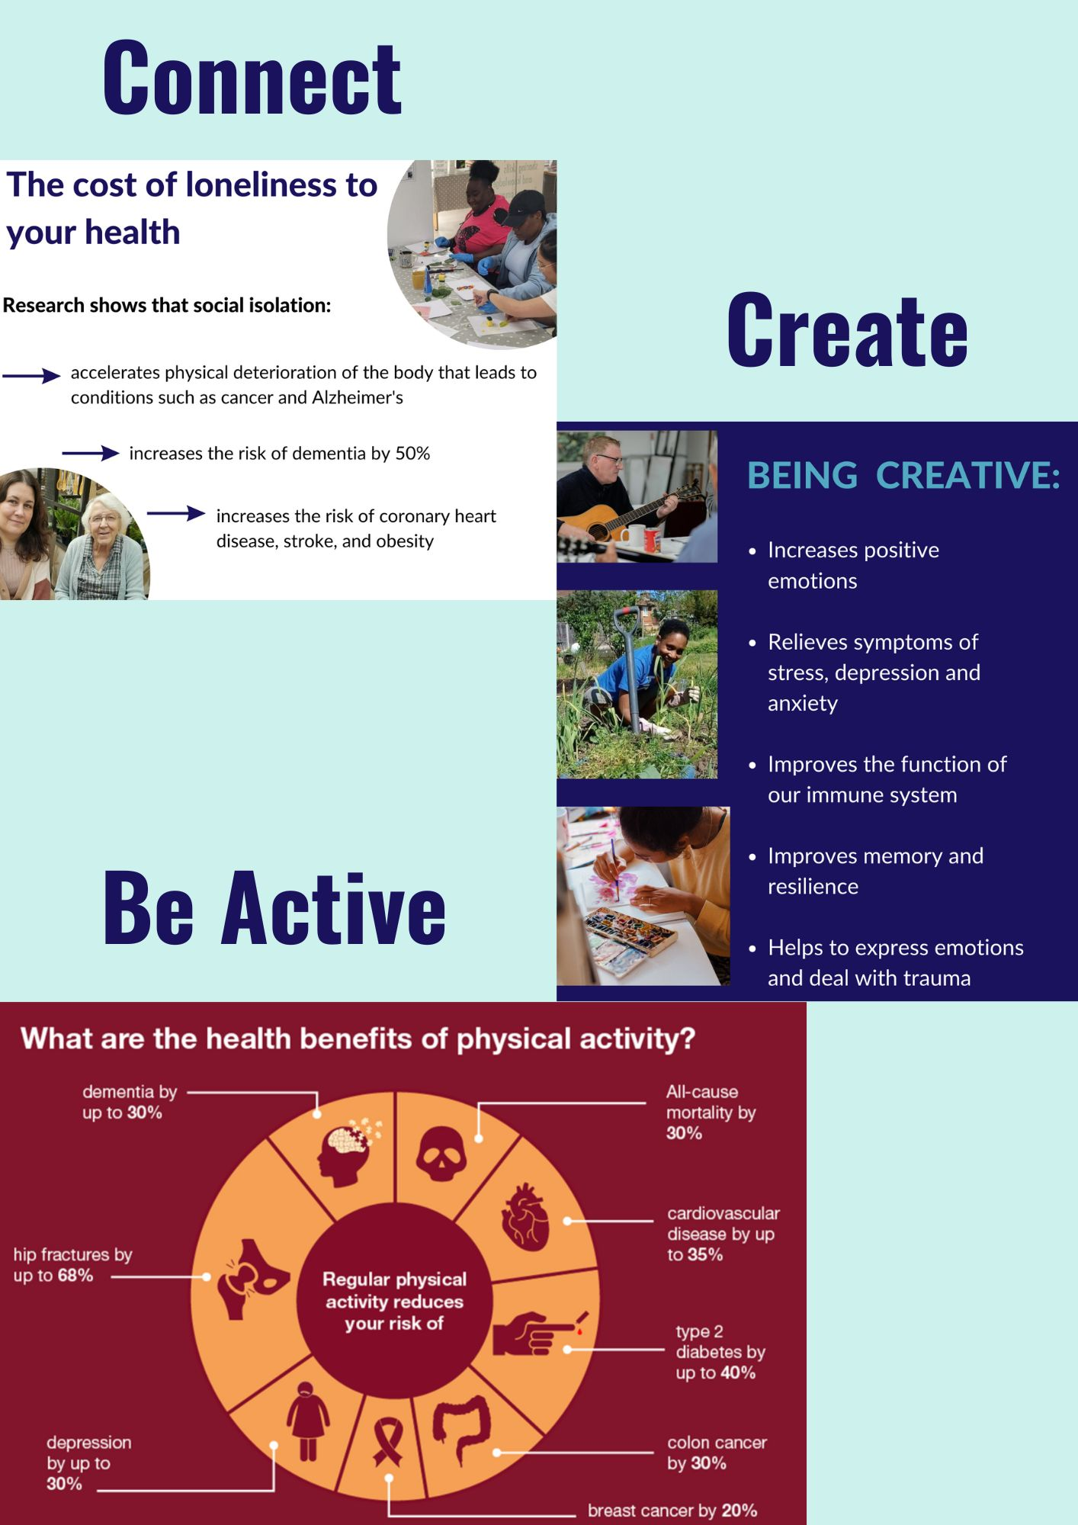

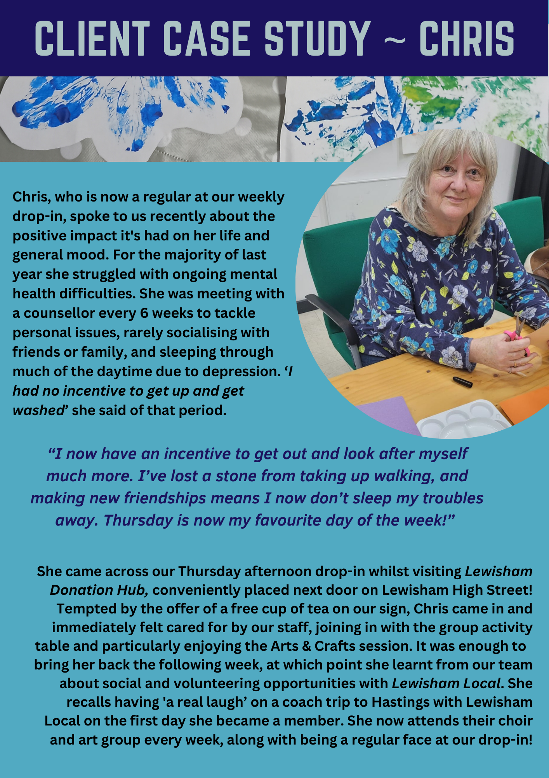
~COST OF LIVING SUPPORT~
Support for people facing financial hardship this winter
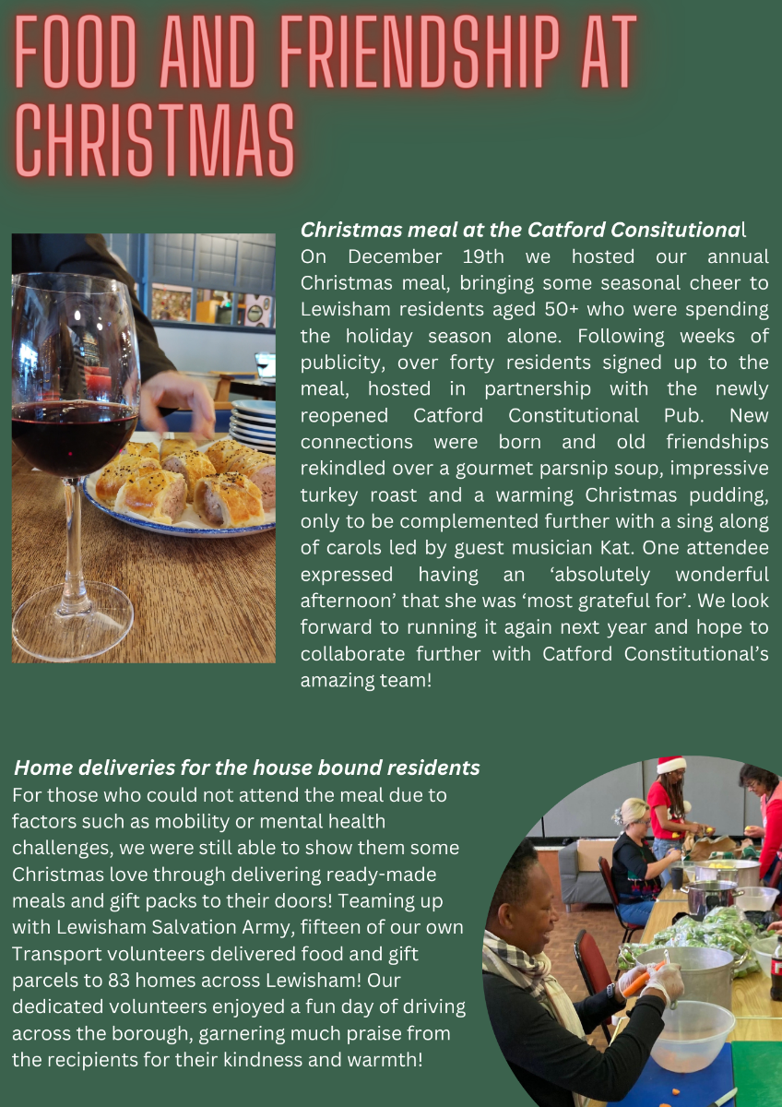

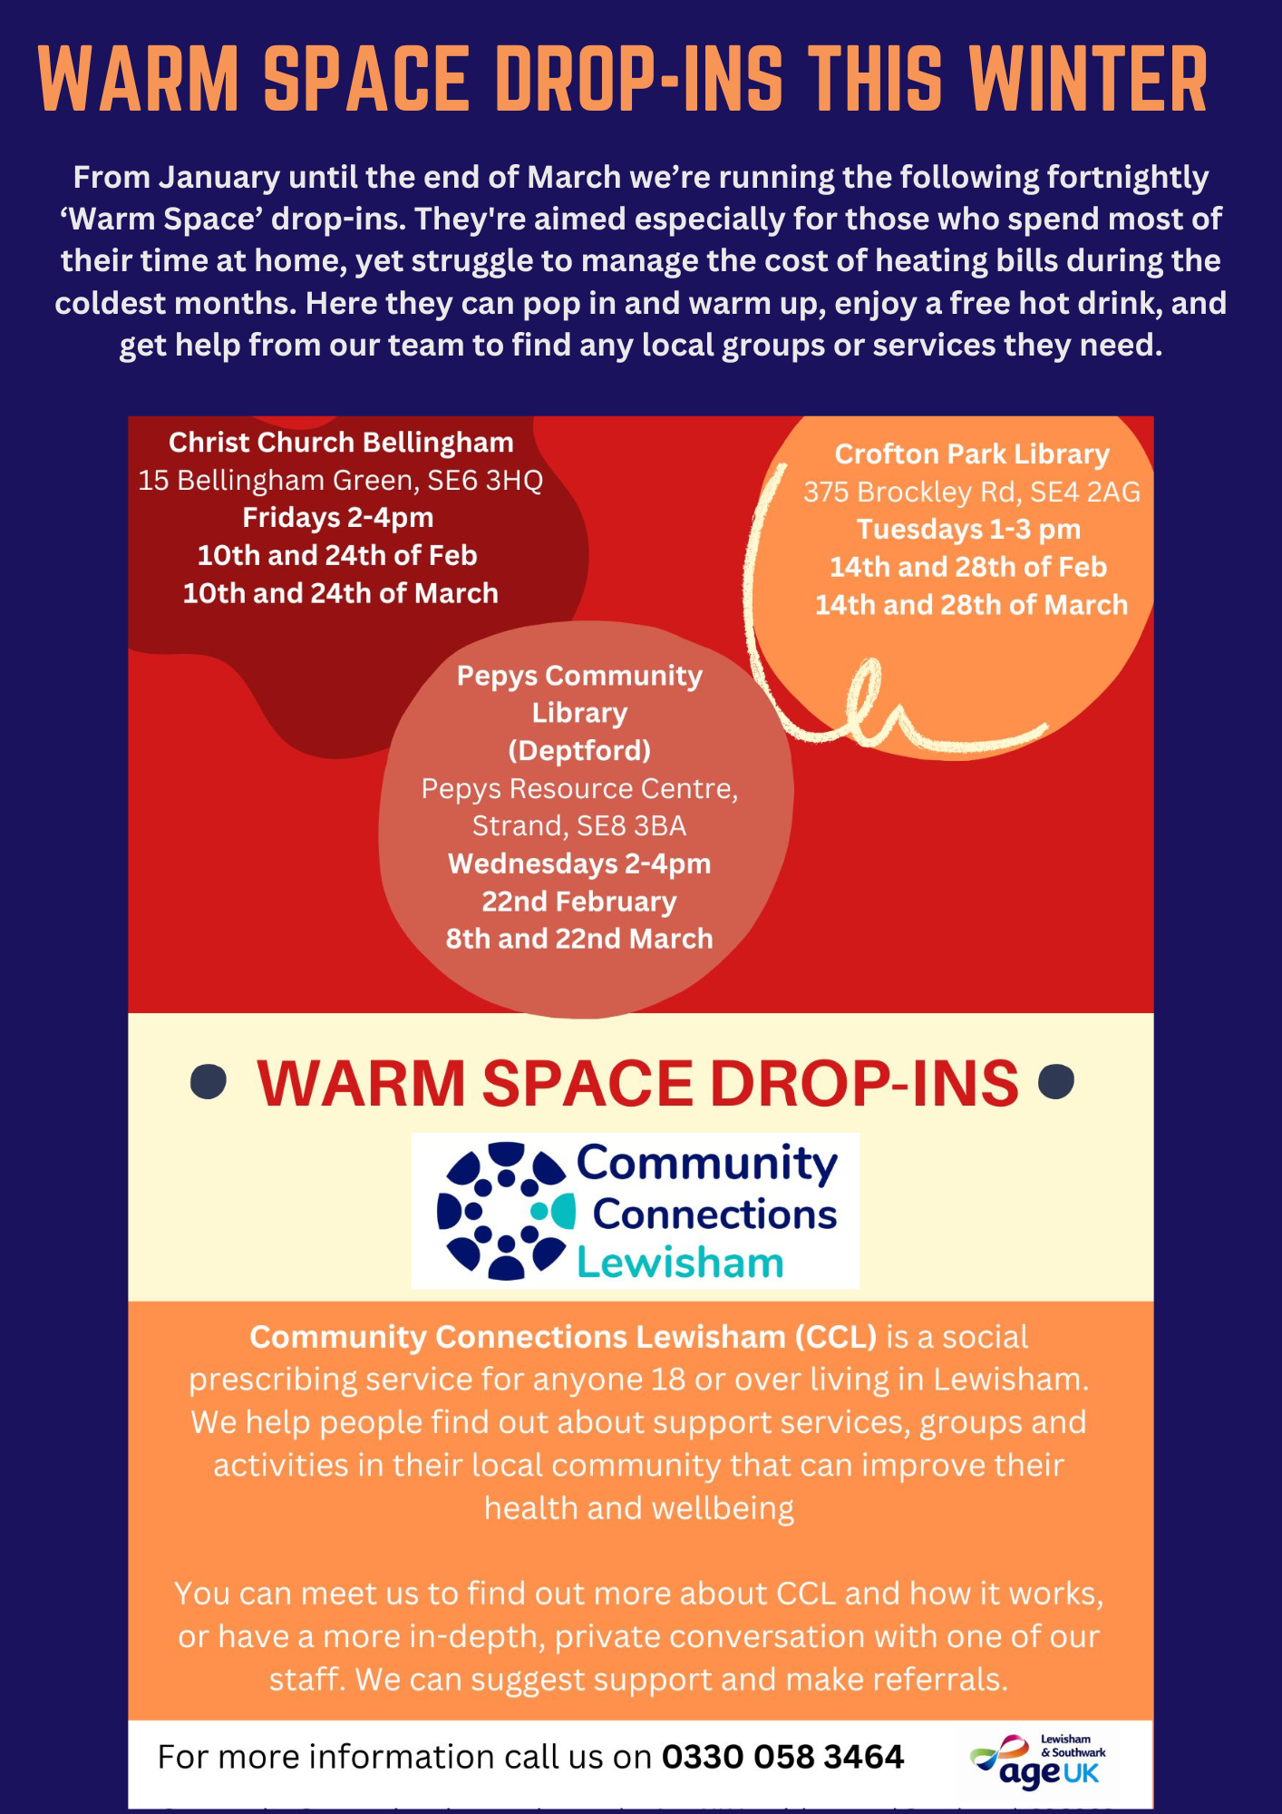

Lewisham Warm Welcomes
Our own warm Space drop-ins are just the tip of the iceberg, however! Since the start of this year an expansive network of local establishments have been offering their venues as free warm spaces for those hit hardest by rising costs and plummeting winter temperatures.
The initiative, known as 'Lewisham Warm Welcomes' has been coordinated brilliantly by Lewisham Local, resulting in their comprehensive ‘Warm Welcomes’ map and leaflet, detailing all known locations, their weekly opening times, and what they each individually offer e.g. free hot drink, meals, social activities and/or or advice services.
Find out more and download the Warm Welcomes Leaflet HERE
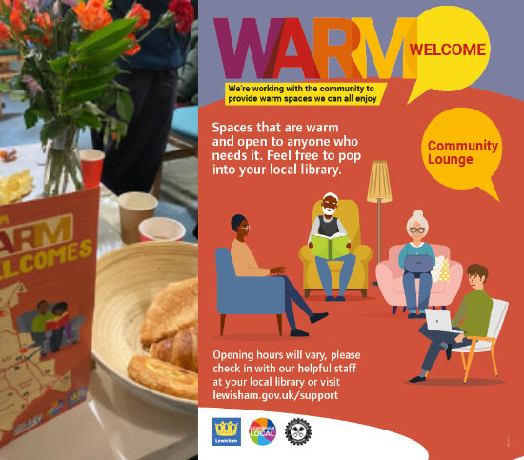
Free energy advice and support from South East London Community Energy (SELCE)
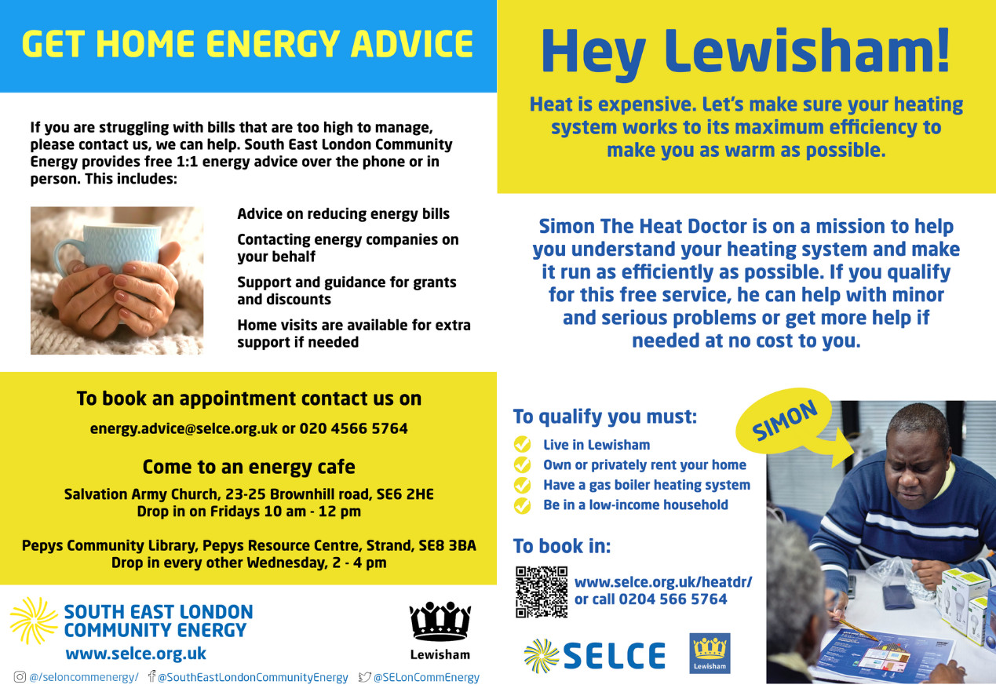

COMING SOON

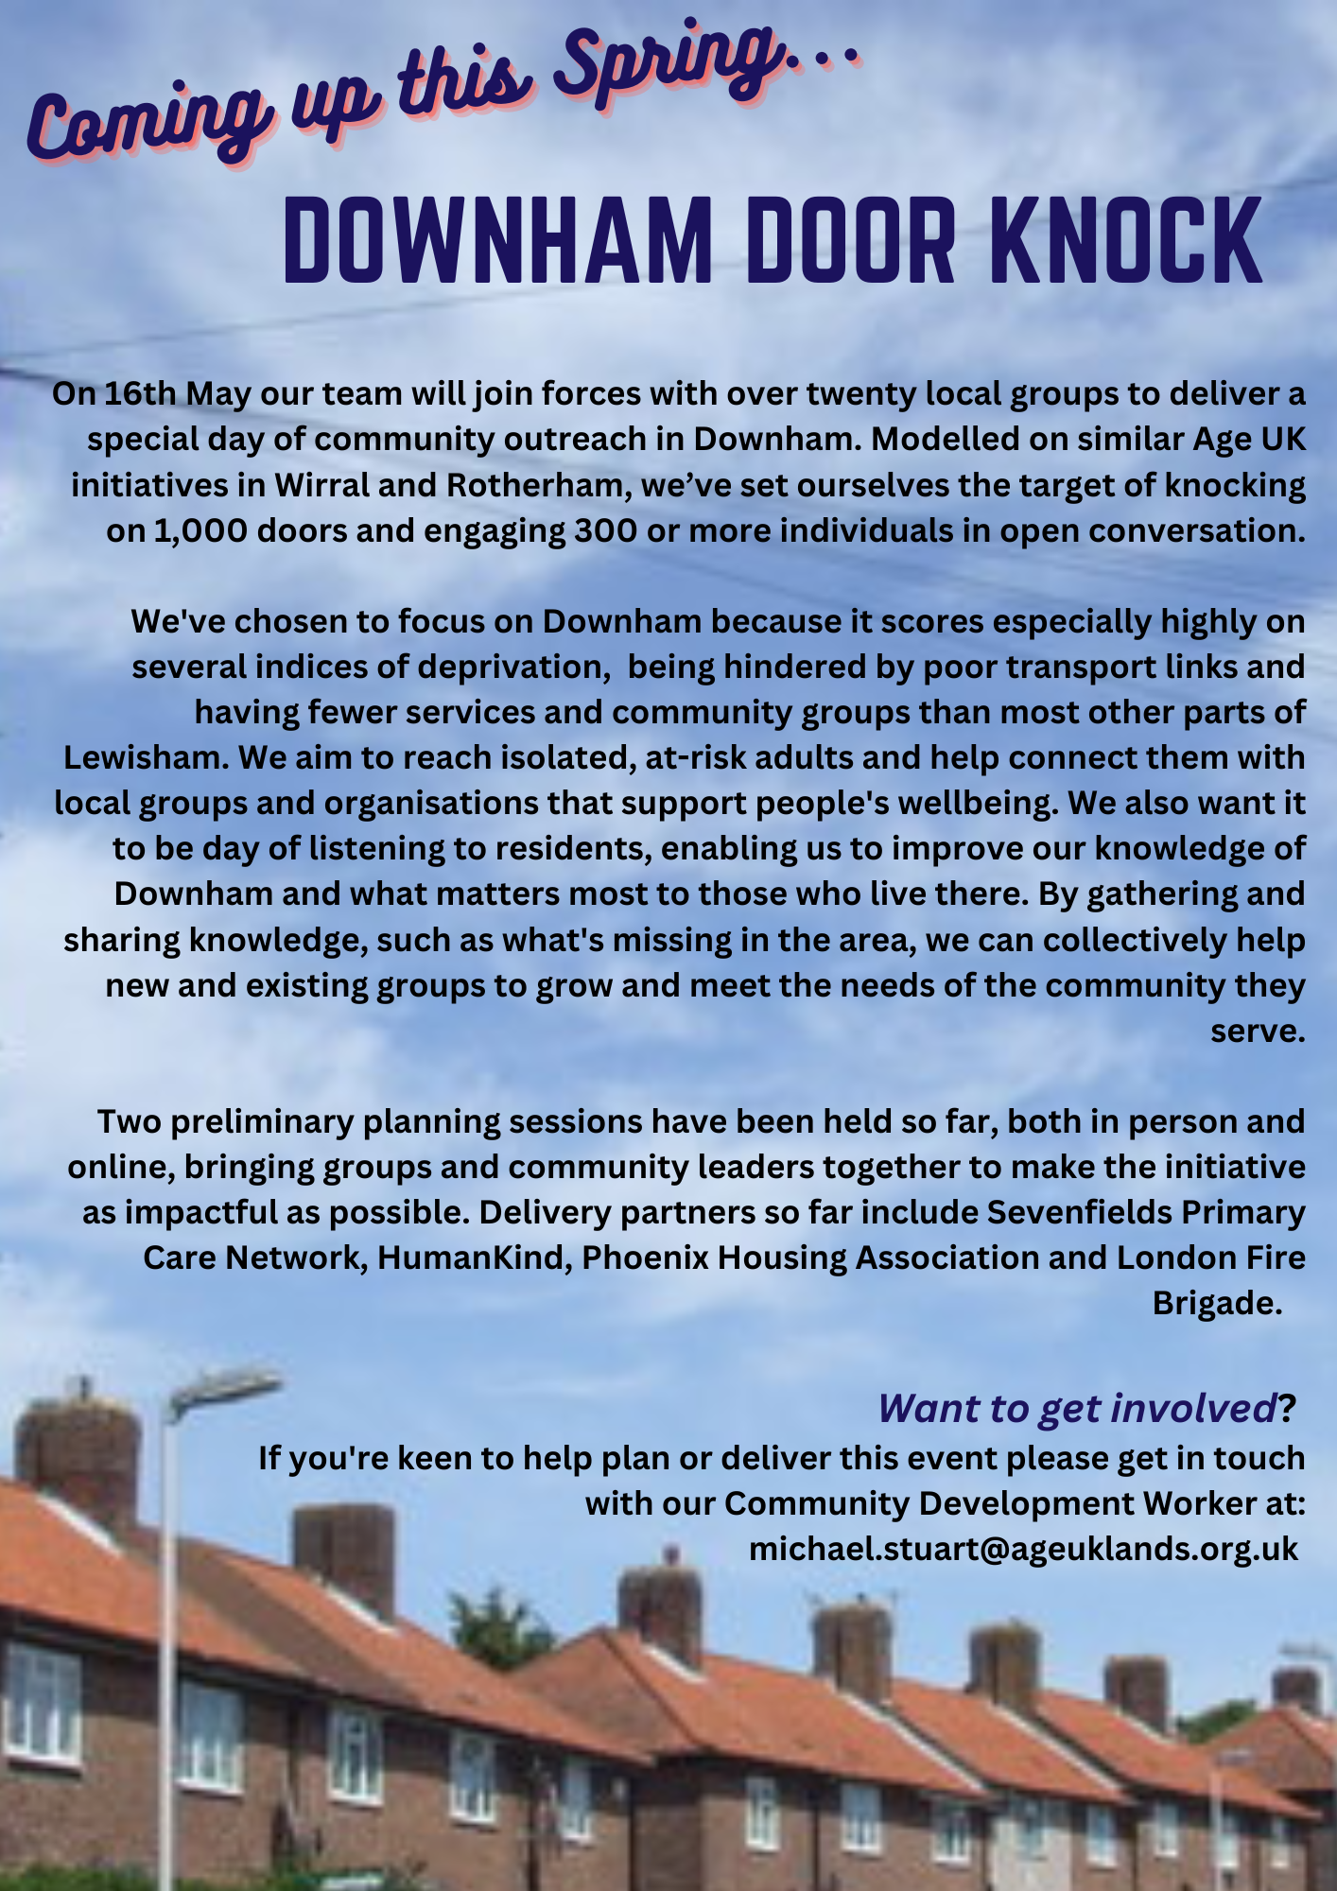

~VOLUNTEER WITH US~
TRANSPORT & BEFRIENDING

VOLUNTEERS NEEDED!
Could you or someone you know spare an hour or more each week to support an isolated resident? If so, we’d love to hear from you!
The success of our Transport and Befriending projects is wholly reliant on our team of dedicated volunteers. In order to meet the needs of our current waiting list and take on more referrals we need to recruit more befrienders, Car drivers and Travel Companions as soon as possible.
Find out more/Apply:
You can now download the role descriptions and apply to volunteer using our simple website application forms here:
Community Connections Transport ~ Volunteer Application page
Community Connections Befriending ~ Volunteer Application page
Please share this with anyone you know or support who is interested in volunteering opportunities!
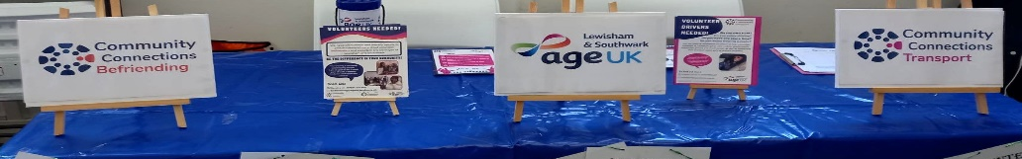

CONNECT WITH CCL

GET IN TOUCH
You can get in touch with us by calling our main helpline on 0330 0583 464, open Monday-Friday from 9:30am-4pm, except on Thursday afternoons when we close at 1pm. You can also visit us at our free Weekly Drop-In, held each Thursday 2-4pm at PLACE/Ladywell, 261 Lewisham High Street, SE13 6NJ.
Find out what services are available in Lewisham for a particular support need - Online Community Directory
Our range of helpful factsheets are freely available to view and/or download from our website ('Community Directory' menu heading). We continue to update and add to these, which include Financial Hardship, Employment Support, Community Transport, Digital Support and Mental Health Support.
Get regular Email updates about local groups and services
To receive regular updates about social groups, activities and support services around the borough, please sign up to our Community Development Worker's mailing list by dropping a quick email to michael.stuart@ageuklands.org.uk
GIVE
Any donations we receive will help us expand our outreach to isolated residents and sustain services like our Drop-in and our new Transport and Befriending projects. Please visit our website DONATION PAGE where you can find out more and support our campaign.
THANK YOU

